Risk Assessment for Bedworth Disabled Swimming Club

Risk assessments are concerned with identifying the hazards (i.e. things which might go wrong or cause an accident/injury), evaluating the likelihood of a particular event occurring (i.e. level of risk) and putting measures in place needed to reduce or eliminate the risk.

Name of Club |  |  | Bedworth Disabled Swimming Club
Name of person completing this form |  | Sheila Carey MBE | Position of person completing this form | Session Leader
Venue for session / event / activity |  | Bedworth Leisure Centre | Place and time of event / activity | Fridays 7pm -8pm
Name of persons in charge of session /activity  (Volunteer committee and volunteer teachers) |  |  | Sheila Carey, Pete Carey, Barbara Lanwarne, Hayley Acton, Jean Noonan, Caroline Williams, Sally-Anne Tully, Phoebe Tully, Judy Newton (occ), Marie Clarke
Risk assessment signed | 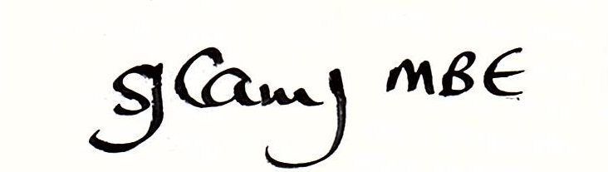 |  | Risk assessment dated | 19/01/2022
Risk assessment to be checked weekly at start of session

Emergency Information

Nearest A&E hospital: | Name and Post code:  George Eliot Hospital, A444  Bedworth By-Pass | Through Bedworth, follow signs for A444 Nuneaton
Working telephone: | Pool landline or mobile: mobile | Number: 07984-590259
First Aid cover | Name of first aiders:  Sheila Carey  Peter Carey  And pool lifeguards / centre staff | Located on poolside

The Risk Assessment

It is essential that who is responsible is fully understood in advance of the activity / session / event and that all staff / helpers are fully briefed.
SJC updated 2023
Hazard | Possible outcome / injury | Mitigation  Who is responsible?  PARticipants/PARents/ Carers ORGaniser
Consider numbers and supervision, working groups and division of available space | Overcrowding, pool capacity exceeded  Risk of drowning / injury / Covid | Pool check-in (Everyone Active). Weekly register. (ORG)  Direction of swimmers to appropriate lane / zone (ORG)  Check that lifeguards are posted before swimmers enter water (ORG)
Child / vulnerable person protection | Inappropriate handling / behaviour | CRB checks / appointed protection officer
Check parental / carer supervision | Level of supervision insufficient for swimmers who require 1:1  Risk of drowning | Ensure that enablers, parents and carers are aware of rules (ORG)
Awareness of NOP and EAP | Members may react to alarm (particularly autistic swimmers) and delay any emergency procedure | Ensure that volunteers are aware of procedures and how to act calmly. Volunteers to be aware of deaf, visually impaired, physically disabled and learning disabled. (ORG)
Medical conditions | Illness or difficulty during session  Risk of drowning / injury | Any medication that is required to be on poolside should be kept safely by a responsible person, preferably medically trained.  (PAR)
Knowledge of medical conditions on a need to know basis | Diabetes, epilepsy etc  Risk of drowning / injury | Volunteer teacher / coach to inform pool lifeguards and / or volunteer enablers of conditions where necessary (ORG)
Awareness of pool rules | Incidents caused by poor behaviour. The pool rules are displayed but some members have learning and behaviour problems. | Simple sign language should be tried in order to communicate what is acceptable and what is not. Parents and carers should reinforce rules. Yellow / red card system for dangerous actions. (ORG/PAR)
Untrained volunteers | Risk of drowning / injury | Volunteers to be fully briefed on their responsibilities and possible difficulties
Contaminated water | Illness | Any person aware to inform lifeguards and stop all activity

