**Raffle Prizes**

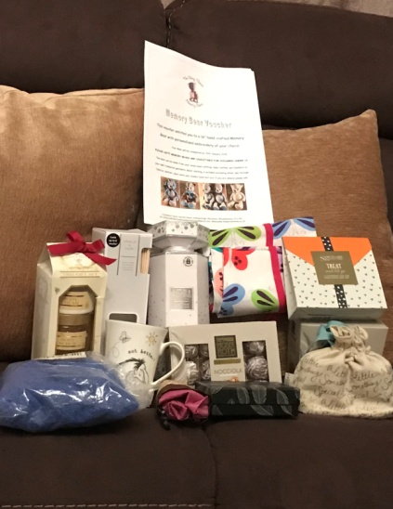A memory bear voucher from The Berry Thieves Memory Bears which entitles the winner to 1 x 16” hand crafted memory bear with personalised embroidery of your choice.

Christmas Cookery book

Royal Jelly trio gift set

Boxed necklace

Whittard silver linings mug (new)

Blue fluffy top shop hat

Vanilla and musk diffuser in box

Set of 2 cotton butterfly tea towels

Sanctuary Spa hands and feet duo set

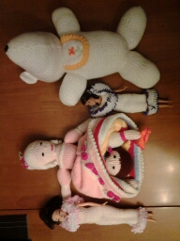Champneys Health Spa bag of delights (body butter and body butter soufflé)

Baylis & Harding limited edition 500ml body wash in gift box.

Small folding shopping bag

Small sports rucksack

Child’s scarf and hat set

Insider’s Guide to Scotland book

Cognac gift set

Gents fold over sponge bag

Cup and saucer gift set

Crazy glasses novelty set

3 Small colour by numbers set Cars/ Planes/ Disney Princess

Bottle of white wine

Gift basket of children’s sweets

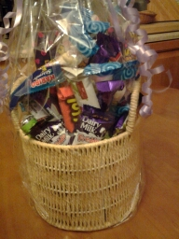Moser Roth Chocolate Truffles

Moser Roth Chocolate Hazelnut Wafers

Knitted two way doll (upside down doll)

Large knitted puppy

Fashion dolls (Cindy/Barbie type) in knitted outfits

Wooden solitaire board with marbles

Pack of Chocolate wafer biscuits

And more……….