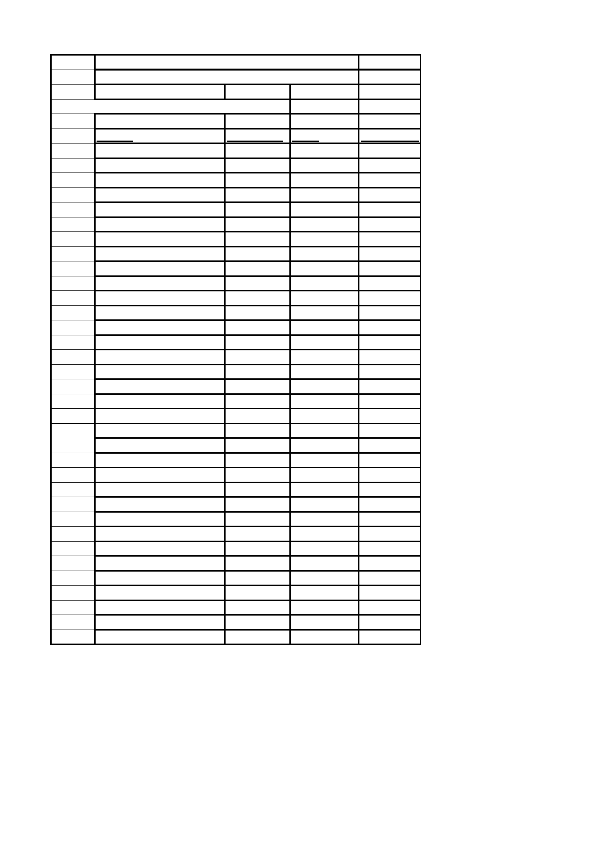
Bedworth Disabled Swimming Club
Speed Rankings (25m times)

Latest update 22.05.14

Name Best Time Date EntryTime

1 Thomas Slater 17.90 11.10.13 17.90 2 Bethany Kelly 18.12 17.05.14 18.12 3 Amy Cooper 19.36 18.05.13 19.36 4 Peter Markham 20.72 17.05.14 20.72 5 Paul McKillop 21.50 16.06.12 21.50 6 Sonia Kelly 22.53 16.06.12 30.00 7 Sheena Baird 23.09 18.05.13 23.09 8 Adam Morton 23.23 08.12.12 23.23 9 Aaron Peters 23.37 17.05.14 23.37
10 Emma Wilson 23.31 18.05.13 23.31 11 Julie Ryan 25.92 11.10.13 25.92 12 Martelle Swinton 26.10 11.10.13 26.10 13 Mark Day 27.33 08.12.12 27.33 14 Tracey Slater 27.57 17.05.14 27.57 15 Helen Fulleylove 27.77 08.12.13 27.77 16 Chris Hubbard 30.10 11.10.13 30.10 17 Karen Finnegan 30.18 18.05.13 30.18 18 Marie Clarke 30.30 08.12.99 42.20 19 Ashley Campbell-Barker 32.12 18.05.13 32.12 20 Chris Lanwarne 34.19 16.06.12 40.00 21 Lisa Haydon 35.15 08.12.13 35.15 22 Edward Davis 36.00 27.04.12 36.00 23 Daniel Hodge 37.11 08.12.13 37.11 24 Evan Marsh 38.90 19.07.13 38.90 25 Gurvinder Garcha 40.07 08.12.13 40.07 26 Clifton Hall 43.00 11.10.13 43.00 27 Claire Marlowe 46.84 19.07.13 46.84 28 Robert Burr 49.70 11.10.13 49.70 29 Leanne Gardner 51.61 17.05.14 51.61 30 Emily Robbins 52.70 11.10.13 52.70 31 Matthew Buckler 53.00 27.04.12 53.00
32 Stuart Croshaw 53.30 11.10.13 53.30 33 Ben Cant 71.00 11.10.13 71.00

