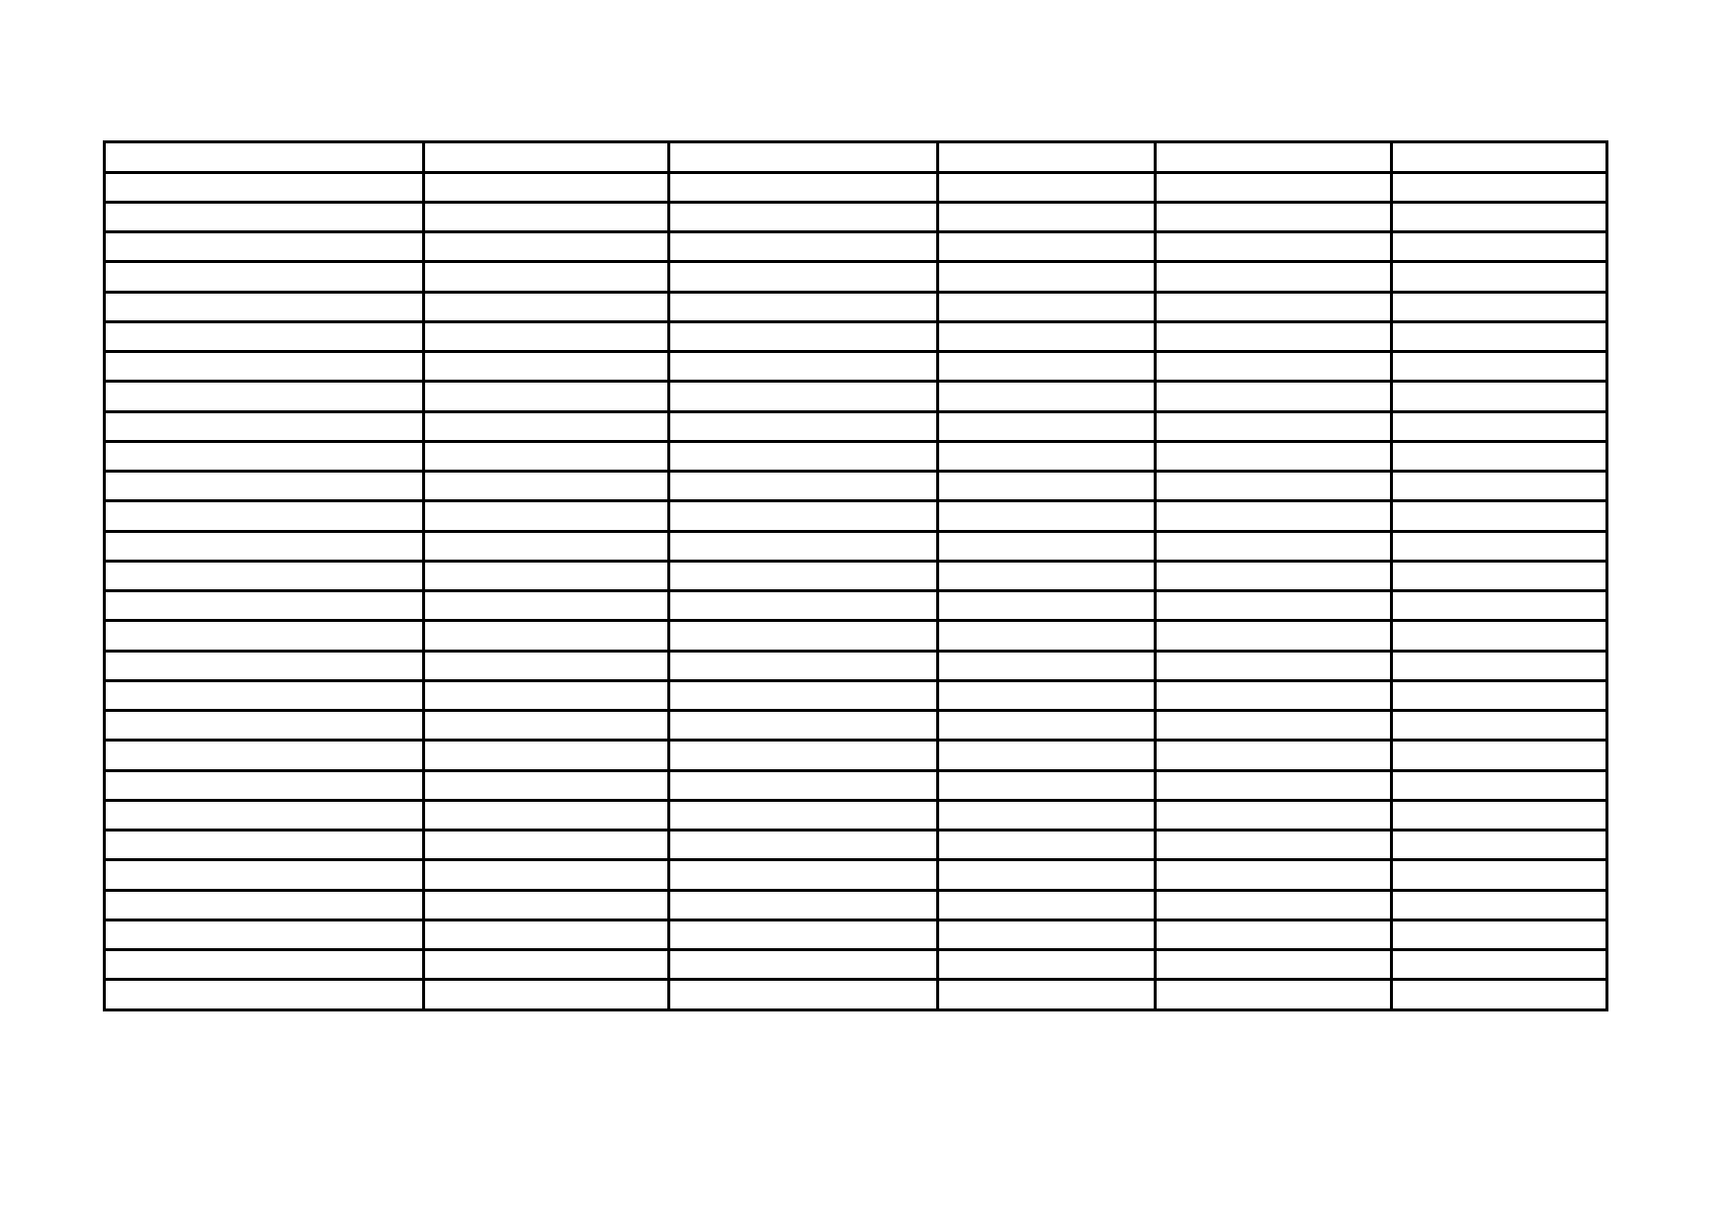
Tamworth Gala 17th May 2014 Extracted Results
Name Group 25m Freestyle 25m Breaststroke 25m Backstroke 4 x 25m Relay

Leanne Gardner Youths F (Up to 16 yrs) Silver 52.73 pb Gold 51.61 pb C team 4th

Bethany Kelly Youths F (Up to 16 yrs) 4th 18.12 pb Bronze 23.49 Silver 22.78 A Team Silver

Ashley Campbell-Barker Youths M (Up to 16 yrs) Silver 32.95 4th 45.92 Bronze 45.53 B team 4th

Daniel Hodge Youths M (Up to 16 yrs) Bronze 39.40 4th 53.95 C team 4th

Peter Markham Youths M (Up to 16 yrs) Silver 20.72 pb Gold 28.88 pb Silver 25.03 pb A Team Silver

Aaron Peters Youths M (Up to 16 yrs) Gold 23.37 pb Bronze 37.44 Silver 35.72 pb A Team Silver

Thomas Slater Youths M (Up to 16 yrs) Bronze 17.01 pb Silver 21.25 Speed ticket 19.97 pb A Team Silver

Lisa Haydon Senior F (17-34yrs) 5th 37.87 Gold 41.65 pb Bronze 40.56 B team 4th

Emma Wilson Senior F (17-34yrs) Silver 33.44 Silver 45.54 pb Silver 27.53 Reserve all

Sheena Baird Masters F (35 yrs &+) Bronze 24.87 4th 32.56 4th 29.63 C team 4th

Karen Finnegan Masters F (35 yrs &+) Silver 31.00 Gold 31.96 Gold 29.86 pb

Sonia Kelly Masters F (35 yrs &+) 5th 32.58 5th 35.39 5th 32.38 B team 4th

Tracey Slater Masters F (35 yrs &+) Gold 27.57 pb B team 4th

Chris Lanwarne Masters M (35 yrs &+) 5th 45.97 4th 41.38 pb 4th 40.15 C team 4th

Summary: 7 Bronze Medals, 15 Silver Medals, 7 Gold Medals, 15 Personal Bests and one speeding ticket.

