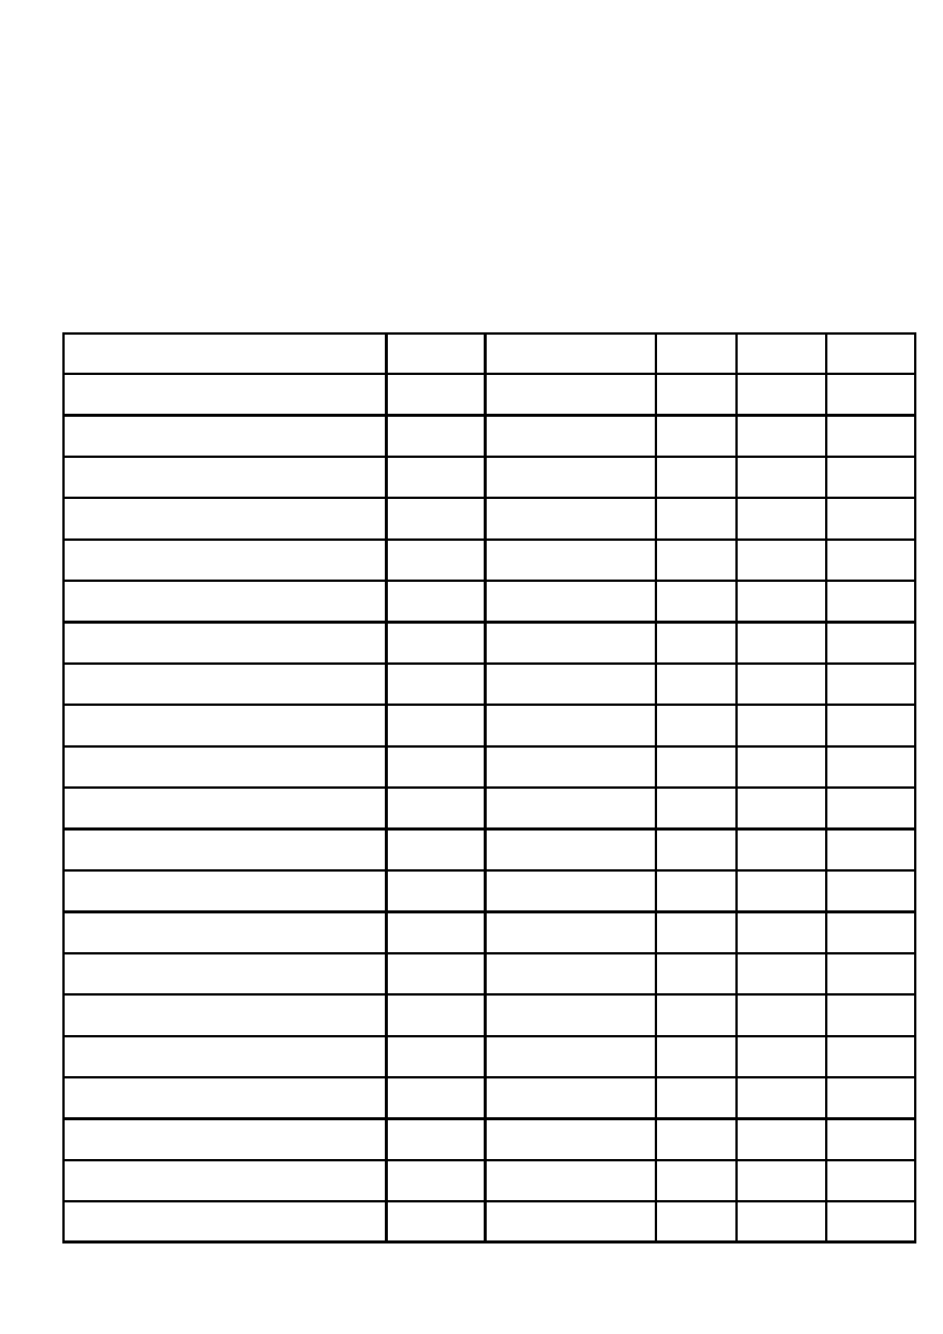
Tamworth Gala

Saturday, 16th June 2012

RESULTS

Name Group Race Time pb Result
Leanne Gardner Youth Width 30.72 30.72 Silver
Bethany Kelly Youth 25m Breast 28.74 28.51 Gold
25m Back 25.64 25.64 Gold
25m Free 20.61 20.4 Gold

Aaron Peters

Thomas Slater

Ashley Campbell-Barker
Youth

Youth

Youth
25m Breast
25m Back 25m Free
25m Breast
25m Back 25m Free
25m Breast
25m Back
47.04 47.04 Gold
37.70 37.70 Bronze 33.81 33.81 SP TK 22.94 22.94 SP TK
28.30 28.30 DQ
19.13 19.13 SP TK 48.97 48.97 Silver 45.40 45.40 Silver

25m Free 37.82 35.62 Gold
Gurvinder Garcha Youth 25m Back 39.78 39.78 Silver
25m Free 47.15 40.80 Silver
Paul McKillop Youth 25m Back 27.55 27.55 Gold
25m Free 21.50 21.50 SP TK
Daniel Hodge Youth 25m Back 48.00 48.00 SP TK
25m Free 52.30 43.31 Gold
Jordan Brace Youth 25m Back 36.58 36.58 Gold
25m Free 37.68 37.68 SP TK

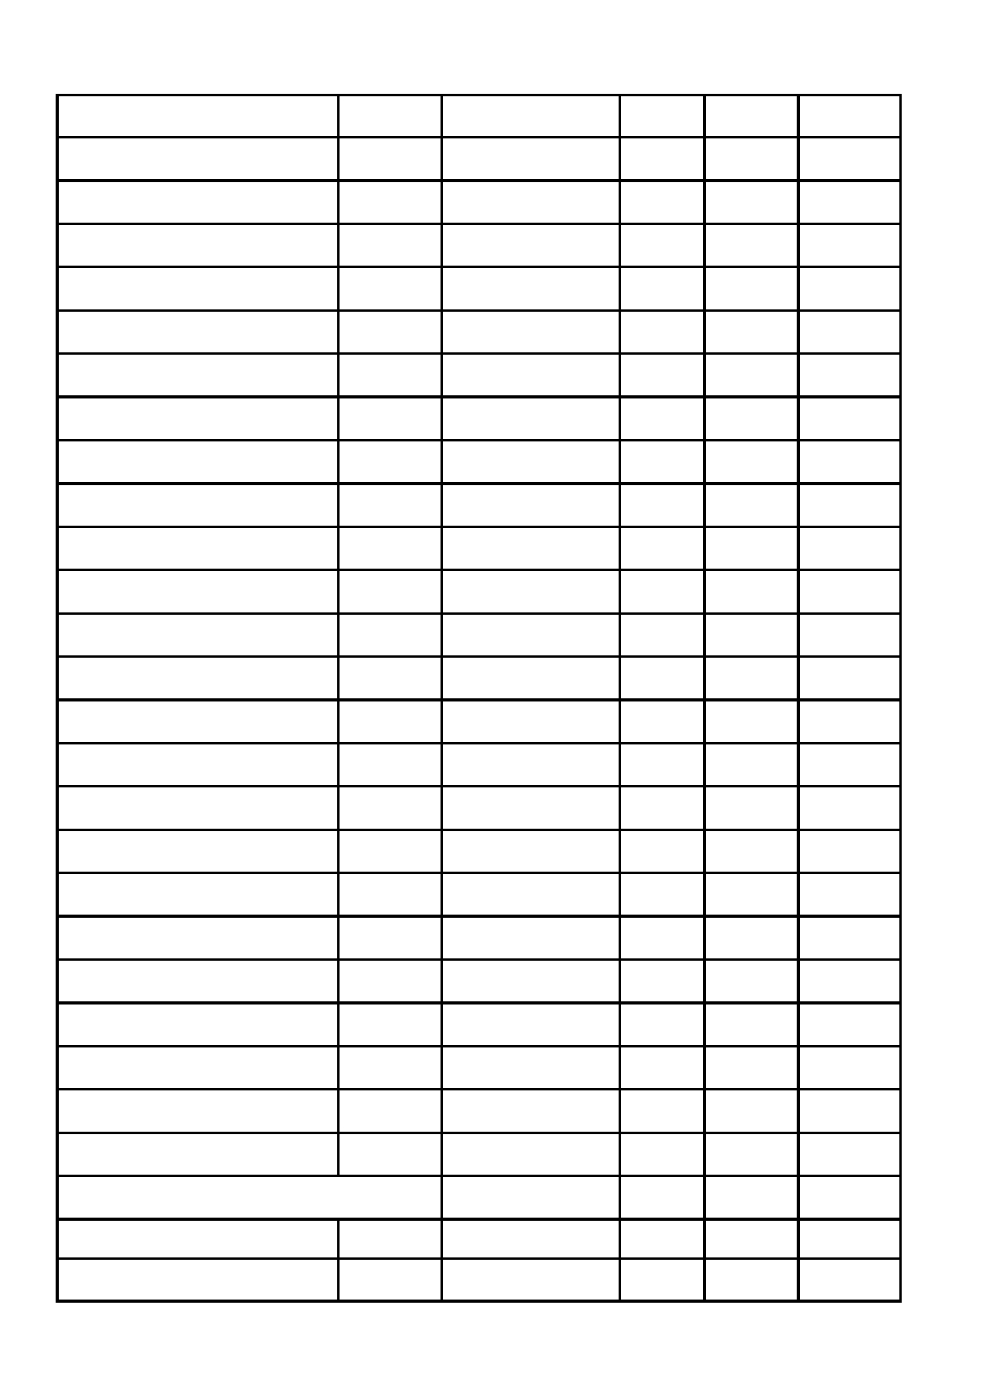
Name Group Race Time pb Result
Marie Clarke Senior 25m Breast 86.76 64.22 Silver
25m Back 61.85 53.09 Gold 25m Free 43.12 30.30 Silver
Emma Wilson Senior 25m Breast 51.02 51.02 Gold
25m Back 34.26 27.45 4th 25m Free 35.42 27.45 4th
Chris Lanwarne Senior 25m Breast 41.25 42.30 DQ
25m Back 34.19 34.19 Gold
25m Free 35.51 34.19 Silver
Mark Day Senior 25m Breast 29.26 28.77 Gold
25m Back 45.06 36.11 4th
25m Free 31.94 27.76 4th
Sheena Baird Masters 25m Breast 29.20 29.20 Gold
25m Back 28.64 26.75 4th
25m Free 23.16 23.16 Bronze
Sonia Kelly Masters 25m Breast 30.65 30.65 SP TK
25m Back 26.53 26.53 Bronze
25m Free 22.53 22.53 Gold
Victor Palmer Masters 25m Freestyle 76.22 61.60 5th

4 x 25m Relay 'A' Mixed Bronze

4 x 25m Relay 'B' Mixed Silver

14 gold + 7 speed tickets
8 silver + 4 relay
3 Bronze + 4 relay

